# 2. General Description

## 2.1 Product Perspective

- Client may use Google authentication tool while signing up for the system.

## 2.2 General Capabilities

User can enjoy the social network experience with features listed below.

1. Friends system (add request, accept, or remove).
2. Begin conversations with other users through chatting.
3. Publish posts either by writing text or uploading images.
4. A timeline page that shows posts from pages, groups, or friends.
5. Create groups and pages and manage them.
6. Interacting with posts (like, comment, share, and save).
7. Follow pages.
8. Manage group chats with multiple users.
9. A Market place where user can publish his products with details (price, picture, description, etc.) or he can visit and check other products.
10. Check top trends to be updated with the real-life events.
11. Search for groups, pages, or people using (name, username, email, or phone).
12. Modify user account settings (change password, and personal data).
13. The system provides statistics about its pages, groups, and accounts to authorized admins and analysts.
14. The system tracker can access to the users’ behavior and check reports.

## 2.3 General Constraints and Justification.

* max response time is 1 second.
* The platforms should be loaded on devices with more than 1GB RAM and screen size range from 14.1 inches to 17 inches.
* The used device should be connected to stable internet connection.
* System can prevent certain users from entering groups with age restriction policies.

## 2.4 User Characteristics

* **Normal user**

The user who can benefit from most features as he/she can check the timeline page, write and publish posts, interact with them (like, comment, share, or save), add or remove friends, chat with others, follow pages, be a group member, create groups and pages, interact with the marketplace, check trends, …etc.

* **Group admin**

Enjoys every feature the normal user enjoys in addition to managing the group (putting age restrictions, remove posts, responding to membership requests).

* **Page admin**

Enjoys every feature the normal user enjoys in addition to managing the page (writing posts, blocking users from the page).

* **Analyst**

Has the ability of collecting statistics such as number of pages, groups, and profiles exist in the

system.

* **System Tracker**

Responsible for tracing users’ behavior and ensuring that they are not violating the rules and checking the reports.

## 2.5 Environment Description

The system is implemented as a web application that can be reached through software tools capable of displaying web pages like “Chrome web browser”.

## 2.6 Assumptions and Dependencies

* The requirement that states: “User can log in through several methods (email/id and password or Google account)” assumes that the new user already has an e-mail address.
* User has the basic knowledge for interacting with a browser.
* User has basic knowledge of English language (beginner level).

## 2.7 Other resources needed

* A database engine based on (SQL).
* Google authentication tool.
* Server supports PHP7+ language.
* A domain host.

# 9. State Diagram

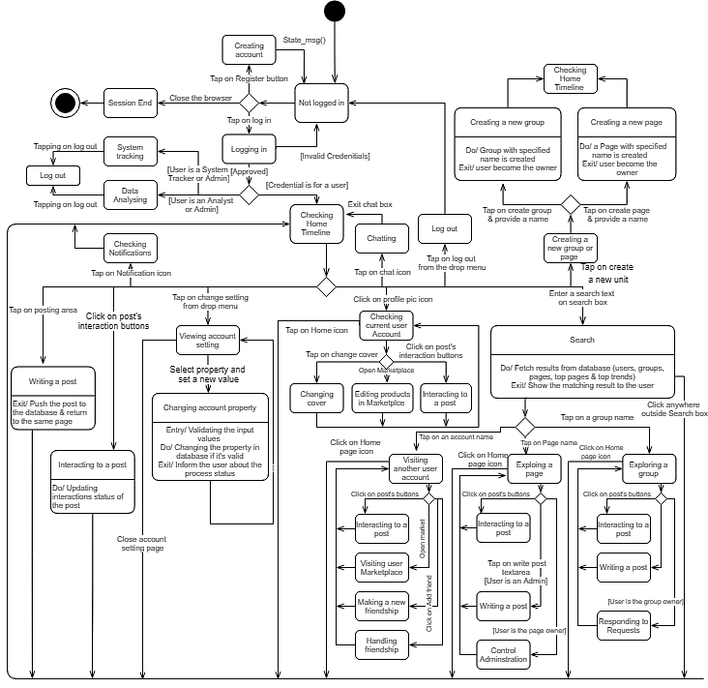

# 11. Detailed Class Diagram

